MACA OATMEAL MUFFINS
[belleenrouge.wordpress.com]
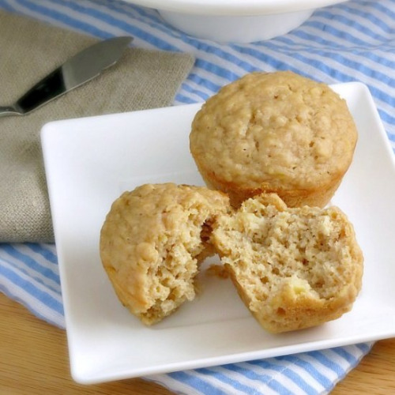
INGREDIENTS
¼ cup maca powder
1 cup oats
1 cup coconut flakes unsweetened
2 tbs butter
2 tbs cinnamon
3 tbs honey
INSTRUCTIONS
- Pre-heat oven to 350° F
- Mix all ingredients in a bowl
- Make small balls with hands or spoon
- Bake in oven for 30 minutes
- ENJOY!

